True North Advantage Plus
The True North Advantage Plus plan assigns a team of 20 specialists to continuously monitor and optimize your website. The team is accountable for results.
Team members are experts in each of their domains and are also skilled in the use of AI tools to augment their work.
Their job is to optimize and then maintain healthy websites. TNA+ monthly retainers follow the schedule of services listed below. TNA+ clients are assigned a dedicated account manager responsible for report preparation and delivery.
At the indicated intervals, Northwoods will deliver:
- Executive summary report for stakeholders
- Scan and audit results
- Compliance scorecard to track progress over time
- Remediation recommendations with prioritized actions
- ROI report per Marketing and Financial goals

Need More language here about the many advantages of this approach.
The services provided are one of everything Northwoods has to offer. Like having your own private team of specialists.
Each of the services with bullets below needs a full page with a useful graphic explaining the services, who delivers, why it’s important, and typical interval of
We will need a way to assess a baseline for each client. Every service has a baseline metrics, or we need to find one.

Service | Daily | Weekly | Monthly | Quarterly | Annually
Uptime Monitoring
SEO Health Check
SEO Performance
Competitive Benchmarking
Privacy and Consent Management CMP
Security and Penetration Testing
Core Web Vital (Speed, Load Times, Google Ranking)
Contact Us Email Delivery
404 Errors (Page Not Found and Broken Links)
Background Tasks Job Test and Verify (CMS Specific)
Site Search Test / Health
Google Analytics
Accessibility (WCAG)
Content (Outdated Content / Images)
UX Review
Content Design
Backup and Disaster Recovery
Proactive Optimization
Event Log
Usability Testing
Status Meeting with Team
Detailed Descriptions
Uptime & Availability Monitoring
- 24/7 global uptime checks (every 1–5 minutes) from multiple locations
- SSL/TLS certificate expiration monitoring
- Domain expiration tracking
- Alerts via email, SMS, or webhook on downtime
SEO Health Checks
- Crawl error detection (404s, 5xx, redirect chains)
- Meta tag, structured data validation, schema validation
- Image alt text
- Robots.txt, sitemap, canonicals
- Mobile-friendliness
SEO Performance
- Traffic analysis
- Page Performance
- Device Insight
- Trend analysis
- Competitive Benchmarking
Competitive Benchmarking
- Monthly performance comparison vs. top competitors.
- Ranking in Core Web Vitals (via CrUX data)
Privacy and Consent Management
- CMP Health (CMP working correctly in all locations)
- GDPR, CCPA, etc.
- Audit cookie practices and third-party data sharing
- New Cookie Detection
- Privacy Policy Text
Core Web Vitals
- Page speed scoring (desktop + mobile)
- Mobile responsiveness
- Compare against industry benchmarks
- Identify overuse of CSS & Javascript
- Identify cache opportunities in CMS
- Identify CDN opportunities
Website Integrity Check
- Automated crawling for broken internal/external links.
- Unused CSS/JS removal
- Orphaned pages detection
- Missing asset check
Backend & Server Health Monitoring
- Error log monitoring
- DNS TTL
- DNS expiration and health monitoring
Accessibility (a11y) Compliance Scans
- Automated WCAG 2.2 AA checks
- Color contrast, ARIA labels, keyboard navigation
- Screen reader compatibility flags
- Check alt text usage
Third-Party Script & API Monitoring
- Performance impact of embedded scripts (ads, analytics, chat)
- Third-party API uptime & response time (e.g., payment gateways)
- Tag manager health (GTM, etc.)
Security and Penetration Testing
- Automated Penetration Testing and results review
- DOS protection review
- Brute Force protection review
- Review access controls and user authentication process
- Check Third Party Integrations for compliance
- Admin access and password hygiene
Consent Management
- Verify cookie consent banners and opt-in mechanisms
- Verify CMP firing correctly from California, Europe, etc.
- Ensure granular control over data collection preferences
UX Consistency
- Navigation clarity
- CTA effectiveness
- Cross-browser/device testing
Content Design
- Content Library check, thumbnail creation
- Ensure brand consistency and tone alignment
- Ensure page layout follows UX best practices
- Identify outdated or inaccurate content
- Validate internal linking and content hierarchy
Legal & Regulatory Compliance
- Review terms of service and user agreements
- Check for required disclaimers (ADA, HIPAA, COPPA if applicable)
- Monitor for new state or international laws affecting digital presence
Google Analytics
- GA4 configuration and tag accuracy
- Confirm proper tracking setup and tag firing
- Verify consent-aware tracking setup
- Data layer integrity
- Ensure GA4 compliance and data retention settings
Backup & Recovery
- Backup frequency and integrity
- Restore testing and incident response plans
- Confirm regular backups and restore testing
- Review incident response plans and data recovery protocols

Pricing
An onboarding will determine the number of monthly hours Northwoods will dedicate to the services outlined above. Typically, 30-40 hours per month are allocated, depending on services mutually agreed upon.
True North Advantage Plus:
- Typical onboarding and startup cost: $xxxx
- Typical 12 Month Retainer: $4,000 - $6,000 / month

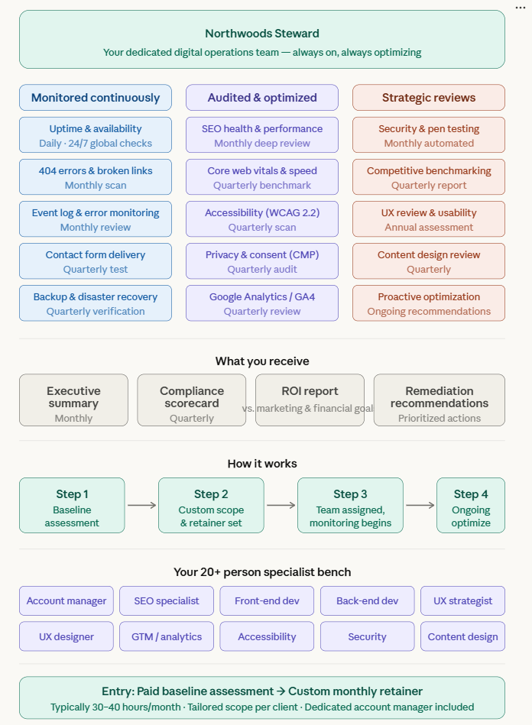
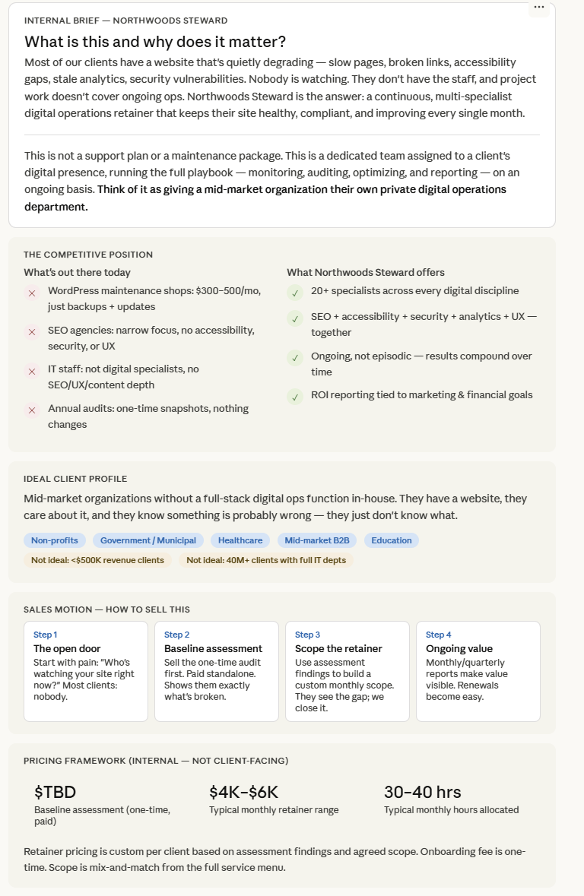
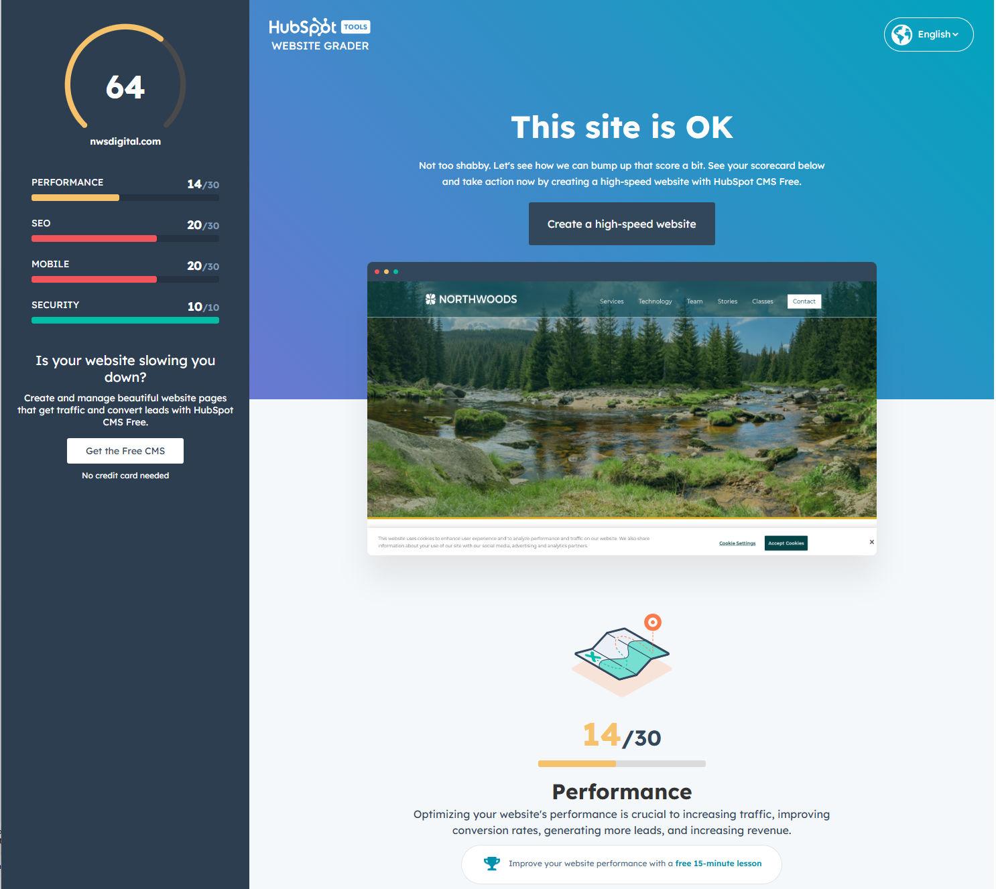

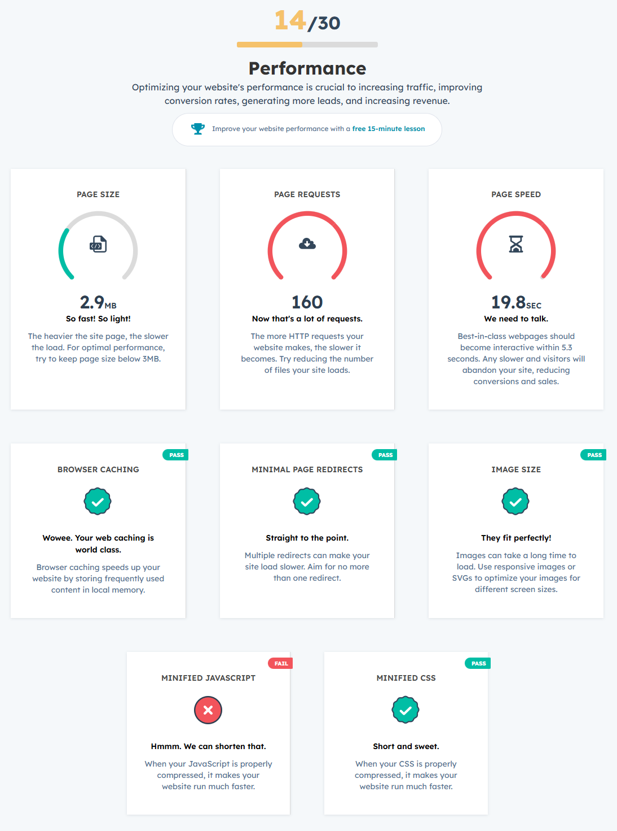
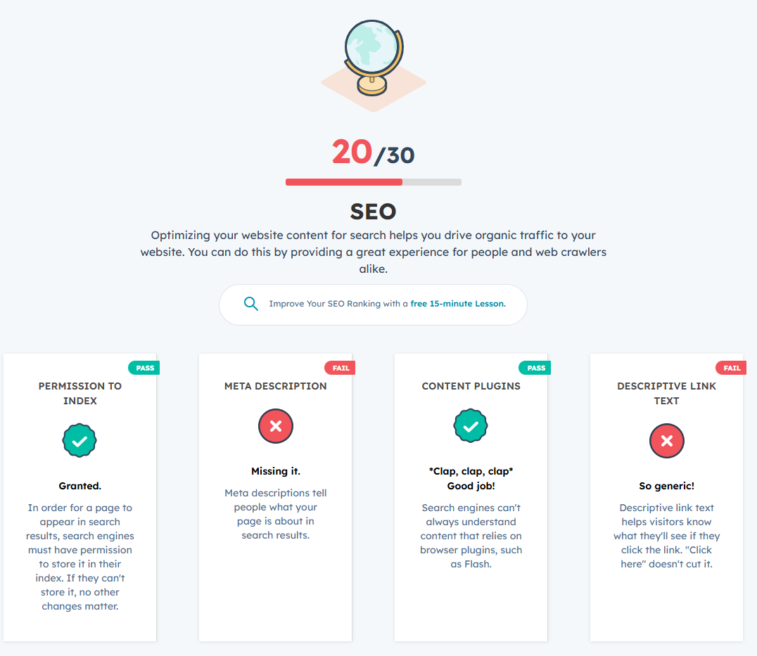

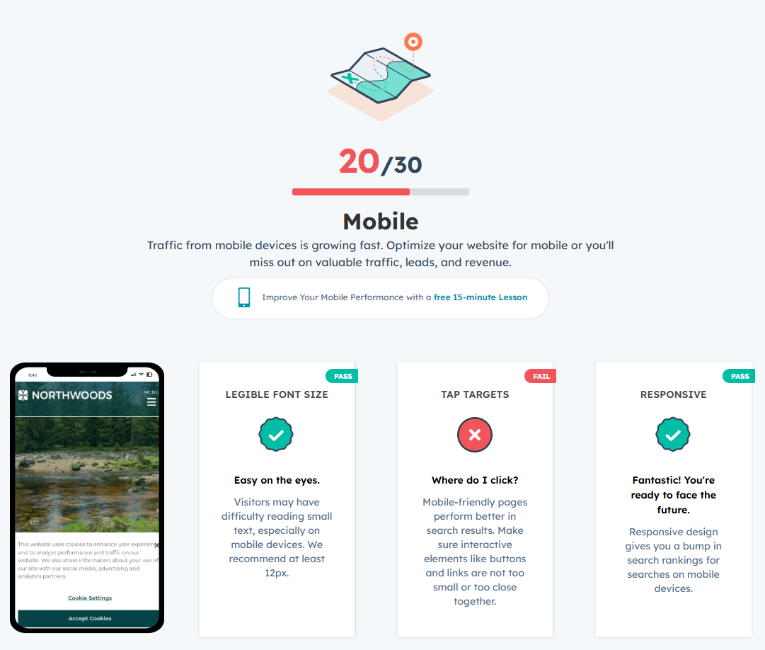

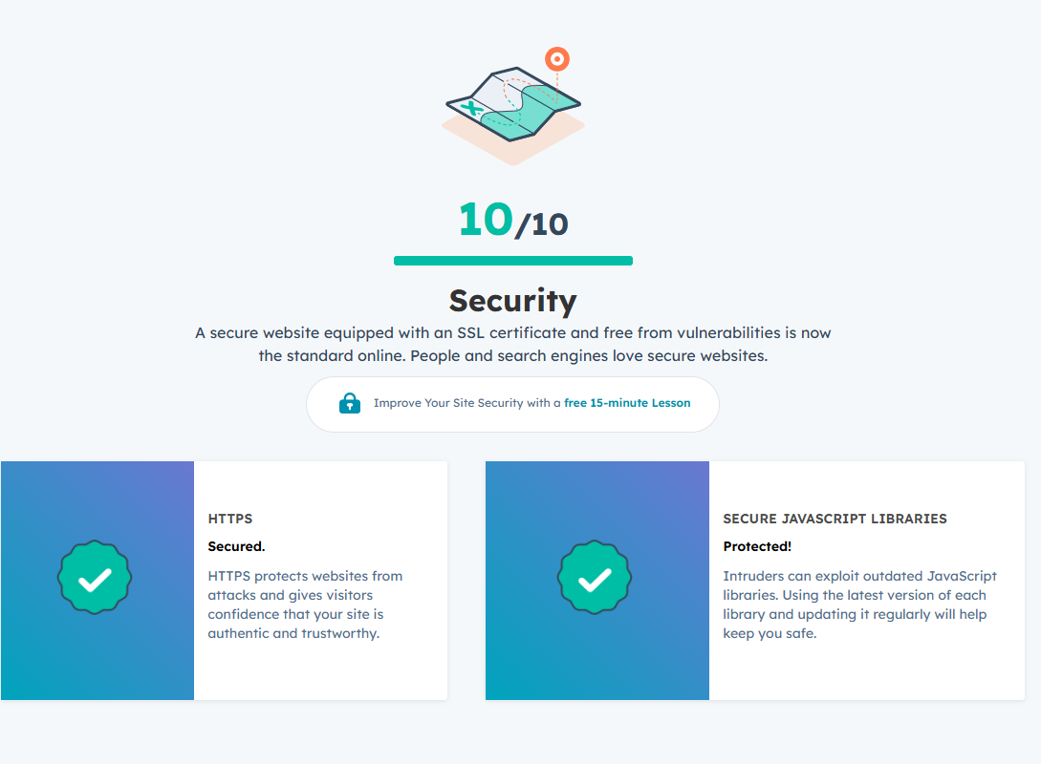

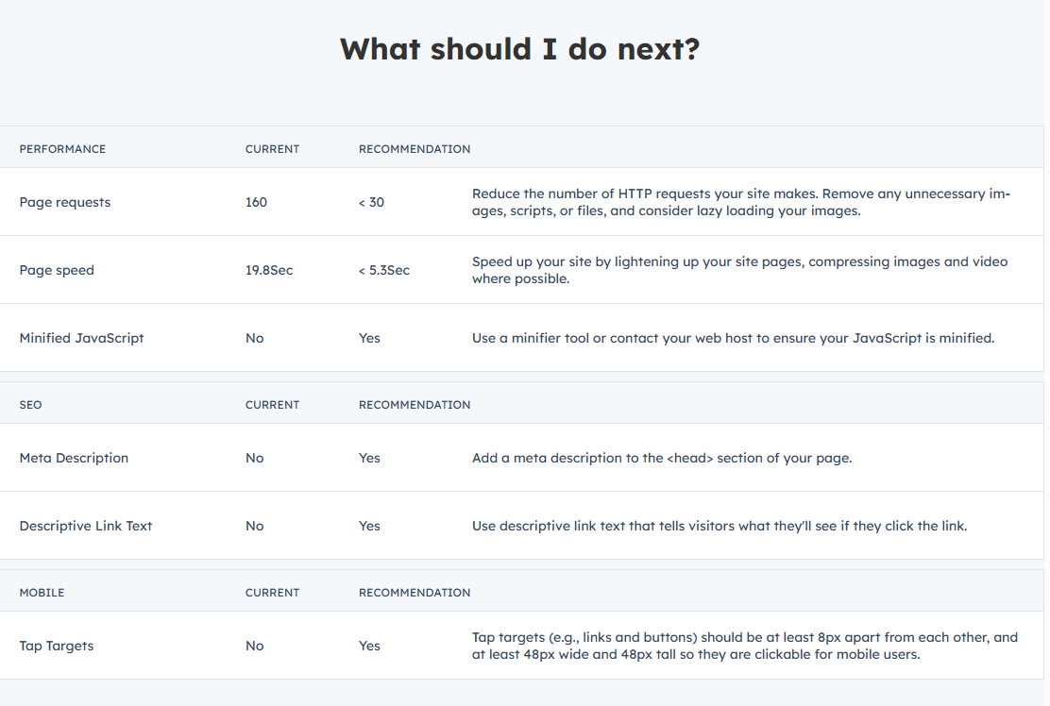
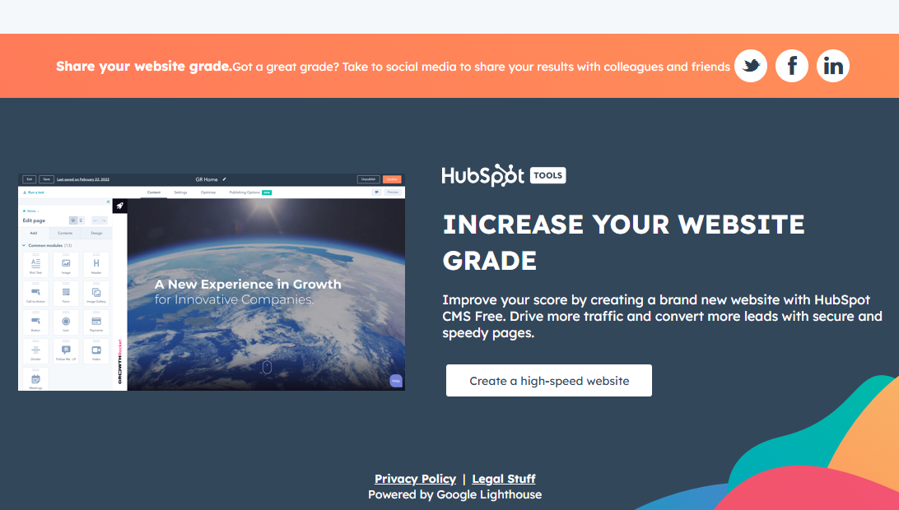

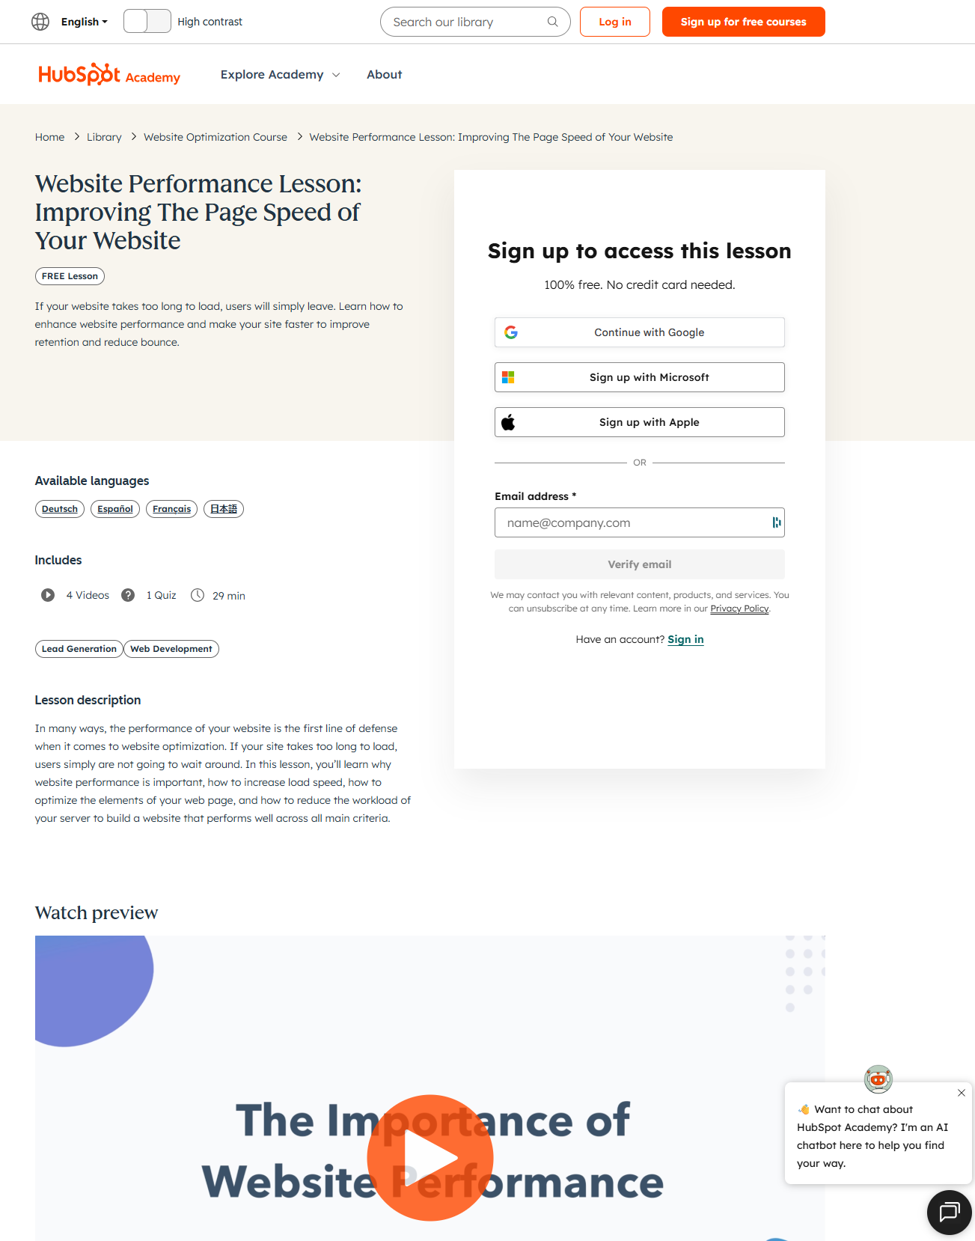
https://academy.hubspot.com/lessons/improving-website-performance?hubs_cta=performance-cta&
––––---

